

**Capstone Design (2)**

**Project Manual**



**Course Name : Capstone Design (2)**

**Professor : SangOh Park**

**Team Name : GoNaMi**

**Team Member : 20160040 Hoyun Ko**

**20163228 Yuseon Nam**

**20164897 Seungyun Lee**

Content

**1.** **Manual for member.** 3

**1)** **Sign up** 3

**2)** **Login** 4

**3)** **Searching for books** 4

**4)** **Book Details Page** 5

**5)** **List of books sold/ books bought** 6

**6)** **My page** 7

**2.** **Manual for seller** 8

**1)** **Registering a book** 8

**2)** **Book box Reservation** 10

**3)** **Put a book in** 11

**4)** **Enter account number** 12

**3.** **Manual for Buyer** 13

**1)** **Buying** 13

**2)** **Take a book** 14

**3)** **Confirmation of purchase** 15

**4)** **Evaluate** 15

**4.** **Manual – Book Box** 16

**1)** **Recognize OR** 16

**2)** **Seller** 17

**3)** **Buyer** 20

# **Manual for member.**

## **Sign up**

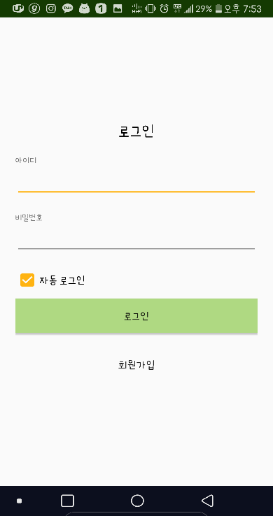 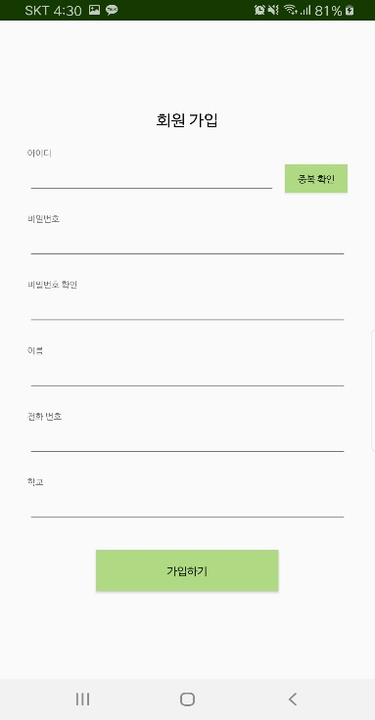

* Pressing the ‘Sign up’ button on the login screen will move on to the sign up screen.
* Check the ID for duplicates.
* If you wrote down all items, click the ‘Join’ button to complete the sign up.

## **Login**

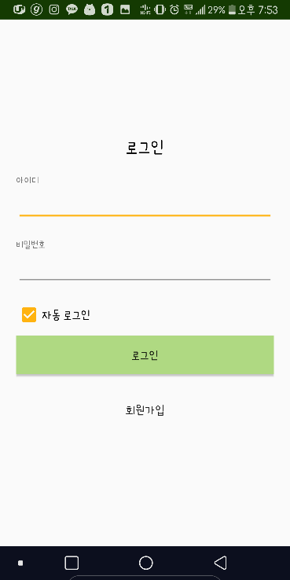

* Enter ID and password to sign in and click the ‘Log in’ button.
* You can also log in automatically.

## **Searching for books**

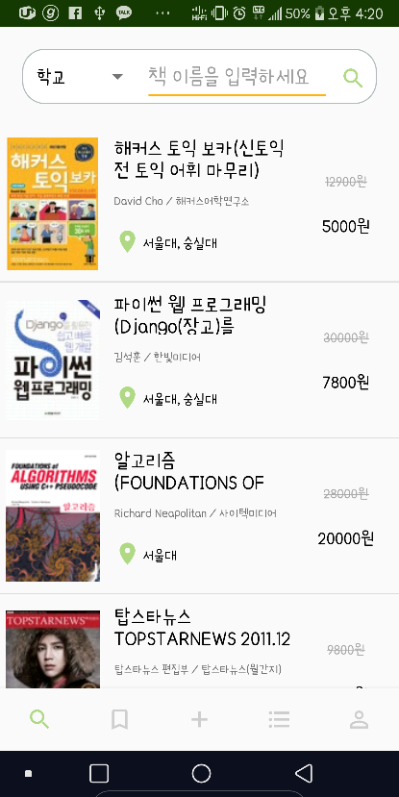

* Tap the magnifying glass tab to view the page where you can search the book.
* You can search books by book name and school.
* Clicking on a book item takes you to a detailed page about the book.

## **Book Details Page**

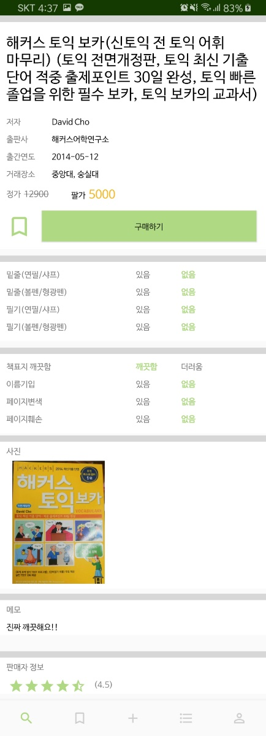

* The book details page allows you to check the book information registered by the seller.
* You can bookmark by pressing the ‘Bookmark’ button.
* You can press the ‘Purchase’ button to proceed with the purchase.
* You can check the seller's rating.

## **List of books sold/ books bought**

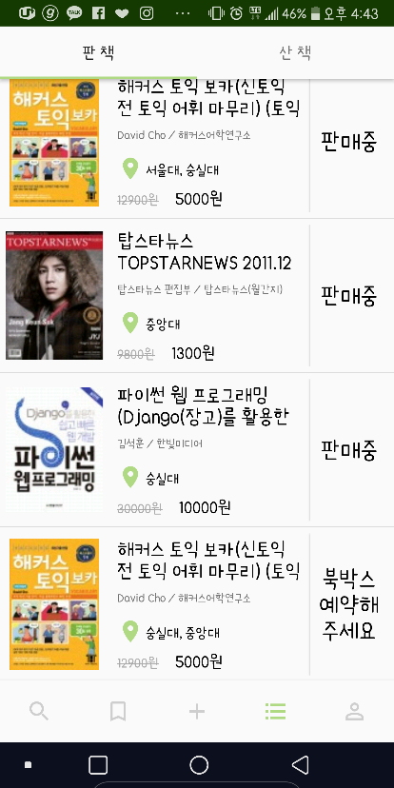 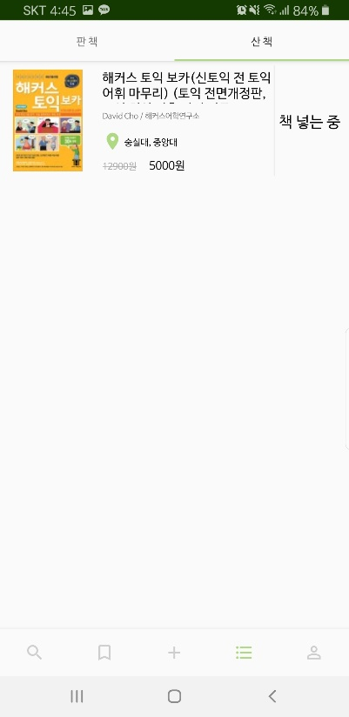

* On the Sold Books tab, you can find a list of books you have sold.
* On the Buy Books tab, you can find a list of books you bought.
* You can check the status of the book and press the ‘Status’ button to move on to the next screen.
* Clicking on a book item takes you to a detailed page about the book.

## **My page**

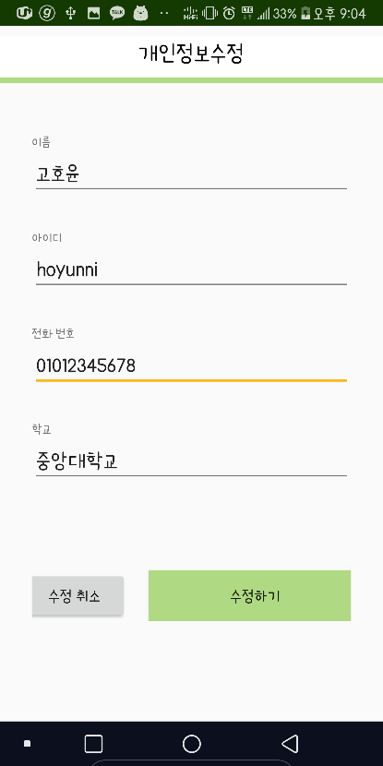 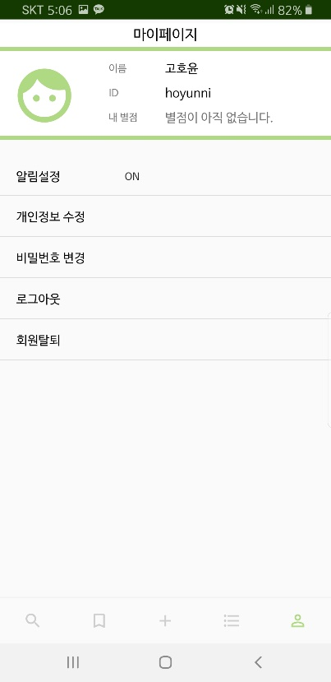 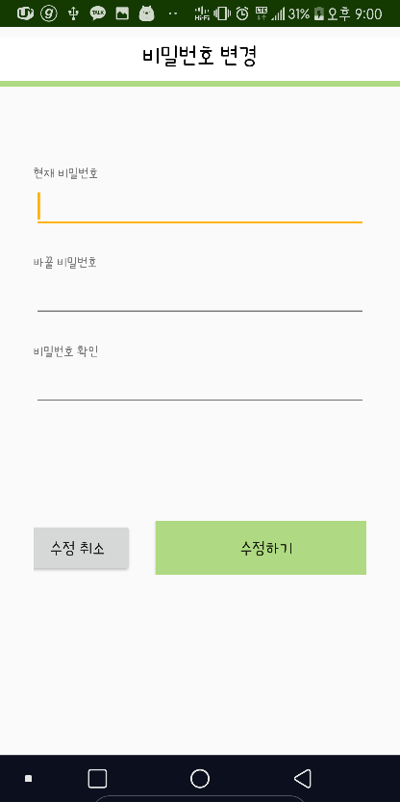

* You can check your name, ID, and rating information.
* The notification settings can be switched on and off using the ‘ON/OFF’ buttons.
* You can modify your personal information, but you cannot change your ID.
* You can change your password.
* Allows you to log out.
* You can withdraw from membership. All information registered upon membership will be lost.

# **Manual for seller**

## **Registering a book**

* **Standard book information**

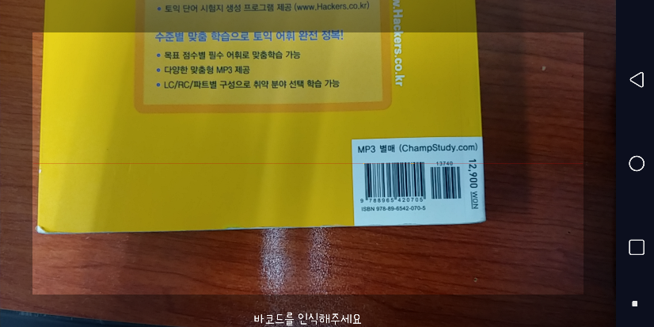 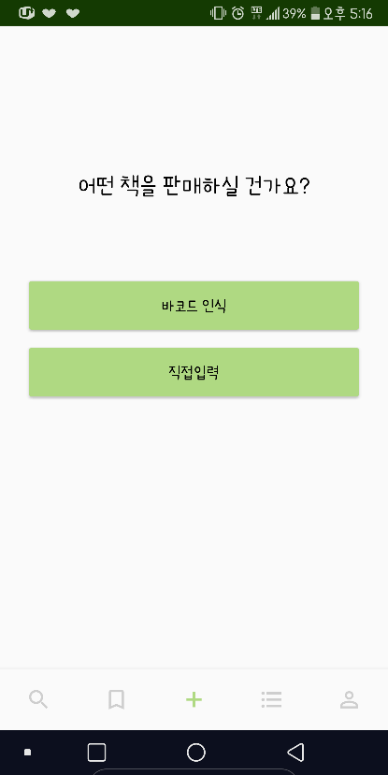 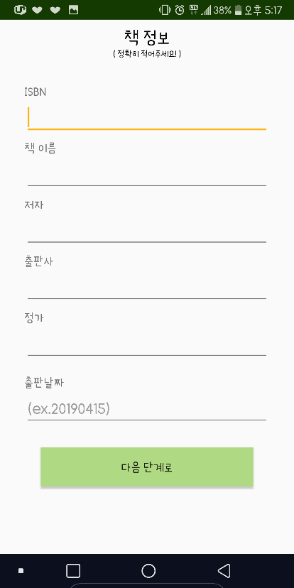

* When registering a book to sell, you can recognize the barcode and register it by entering it yourself.
* When a book's barcode is recognized, the book's information items are filled on their own.
* If you've finished filling out the items, we'll move on to the next level.
* **Seller’s Book information**

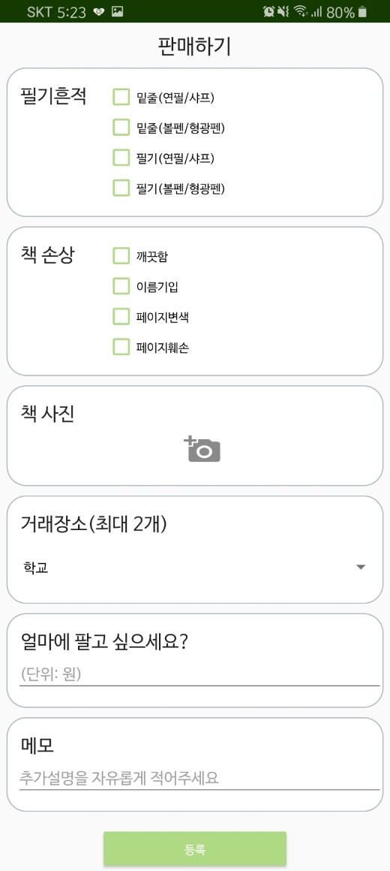 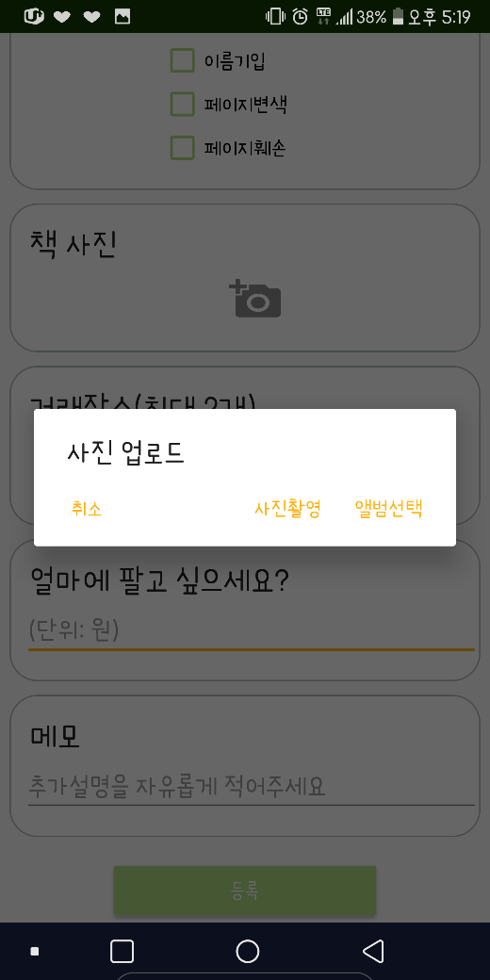

* Check the handwriting/book damage section of your book.
* You can upload up to three pictures of your book. The photo upload can be selected from the album or by taking pictures.
* Up to two trading locations can be registered, and schools can be selected by looking at the list of schools with book boxes.
* If all items are filled, press the ‘Registration’ button to register the book.

## **Book box Reservation**

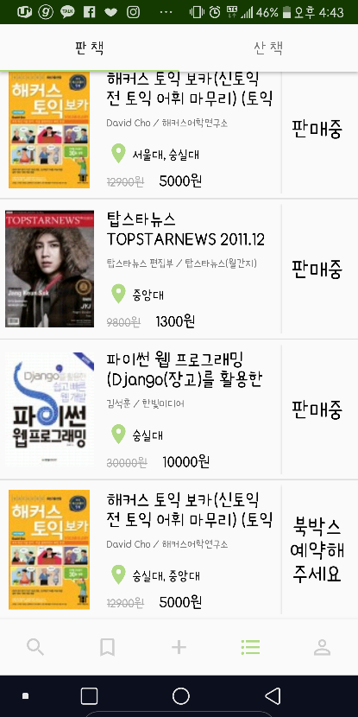 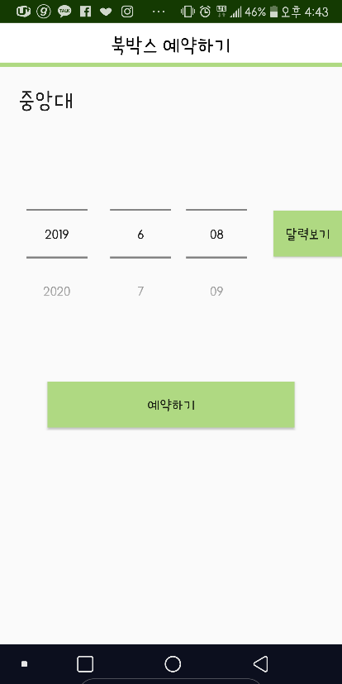 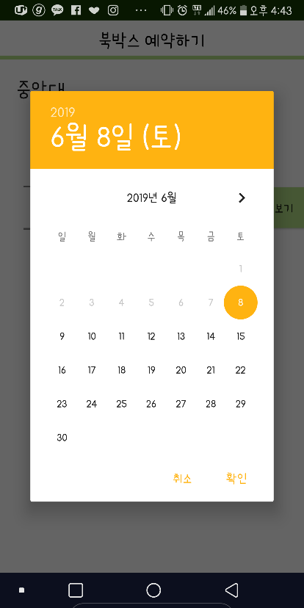

* Click the ‘Status’ button to reserve a book box from the list of books sold, and go to the Book box Reservation screen.
* Book box reservations screen will show the name of the school selected by the buyer.
* When reserving a date for book box, you can select a date using a spinner or a calendar view.
* When you have finished selecting a date, press the ‘Reservation’ button.

## **Put a book in**

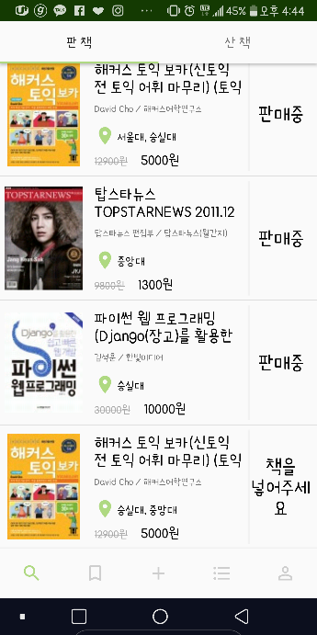 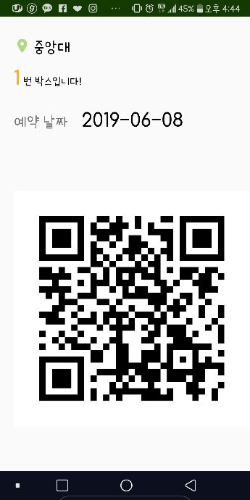

* Click the ‘Status’ button on the list of books sold and move on to the Book box reservation information screen.
* Book box reservation information includes school information, box number, reservation date and QR code with reservation information.
* The following steps can be carried out in the ‘Book Box’ with the QR code.

## **Enter account number**

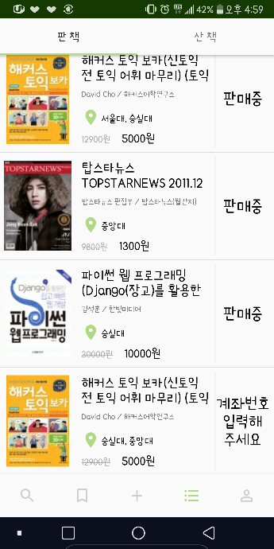 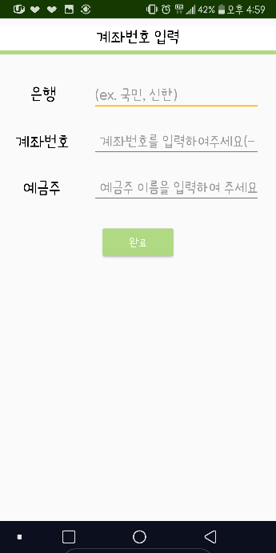

* Click the ‘Status’ button to enter the account number, and you can fill out an account number.
* Enter the bank, account number and depositor and press the "Completion" button.

# **Manual for Buyer**

## **Buying**

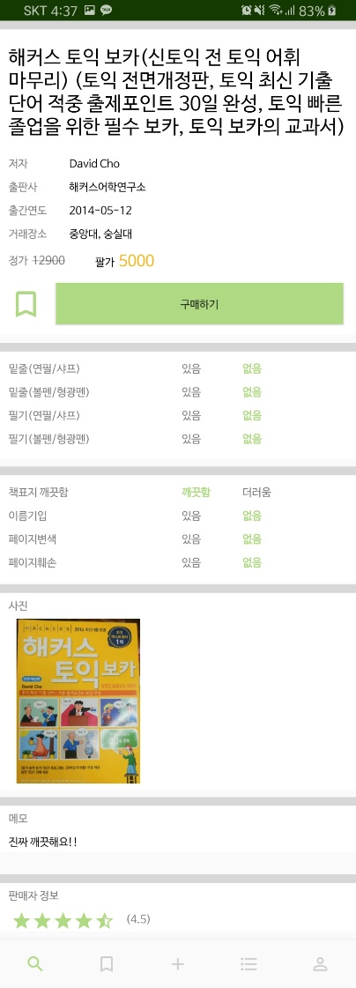 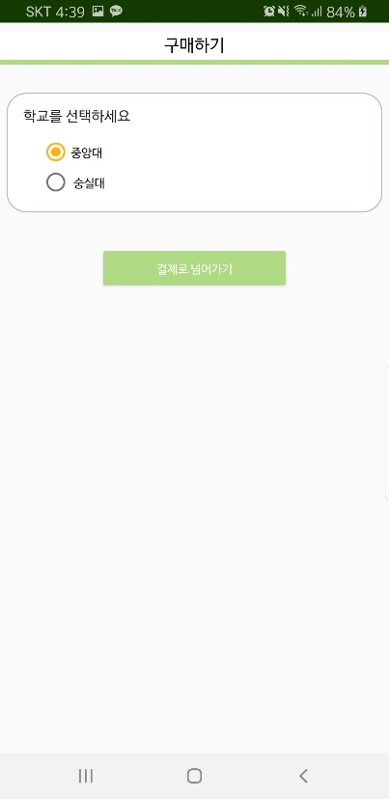 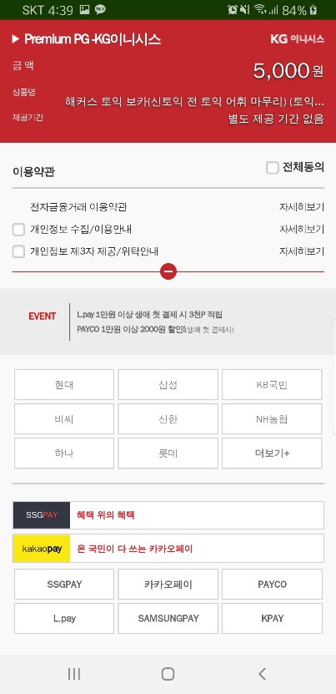

* Click the ‘Purchase’ button on the Details page to go to the Purchase screen.
* On the Purchase screen, select the school you want to trade.
* When you have finished choosing your school, click the ‘Go to Payment’ button.
* Payment will be made in the desired manner and the purchase will be completed.

## **Take a book**

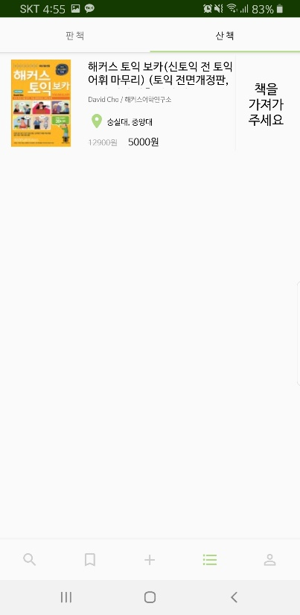 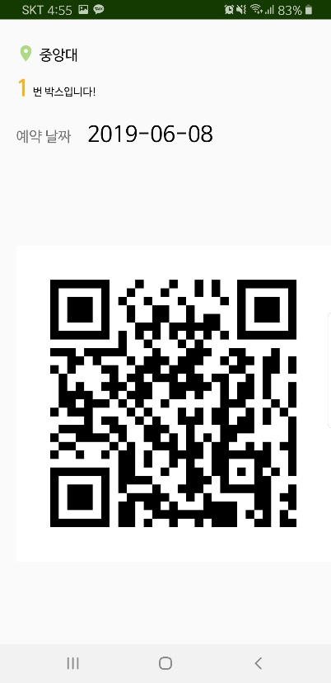

* Click the ‘Status’ button on the list of books bought and move on to the Book box reservation information screen.
* Book box reservation information includes school information, box number, reservation date and QR code with reservation information.
* The following steps can be carried out in the ‘Book Box’ with the QR code.

## **Confirmation of purchase**

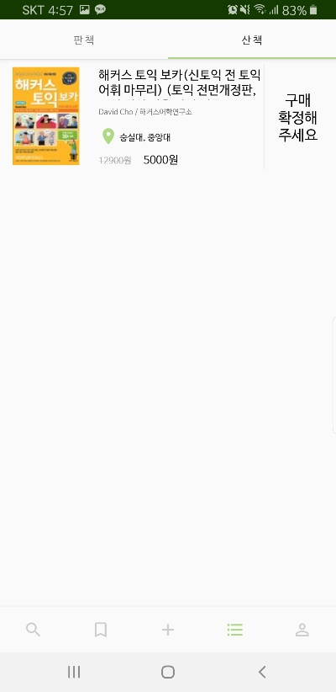 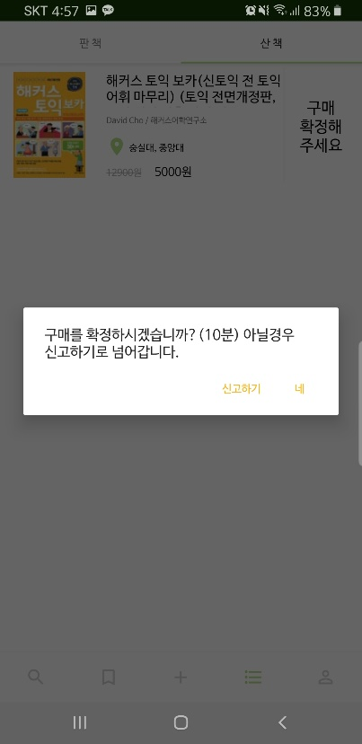

* Click the ‘Status’ button on the list of books bought and choose whether to confirm the purchase or report seller.

## **Evaluate**

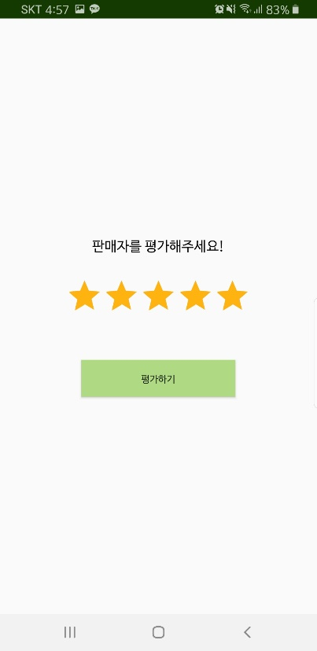

* If you have confirmed your purchase, you evaluate the seller by rating a star mark.

# **Manual – Book Box**

## **Recognize OR**

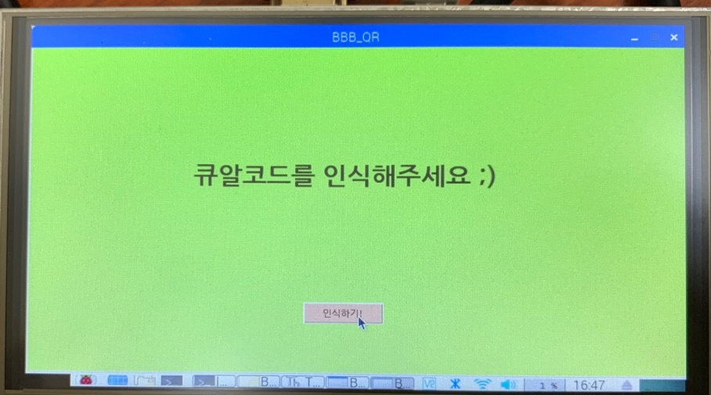

**Check data**

• QR code contains

- ISBN of Book

- Register number of book

- User id

After recognize the data of QR code,

- Book box send decoded data to Server.

- Server check the date, QR data.

- And get information a. whether the reservation is true or false and b. whether user is seller or buyer.

## **Seller**

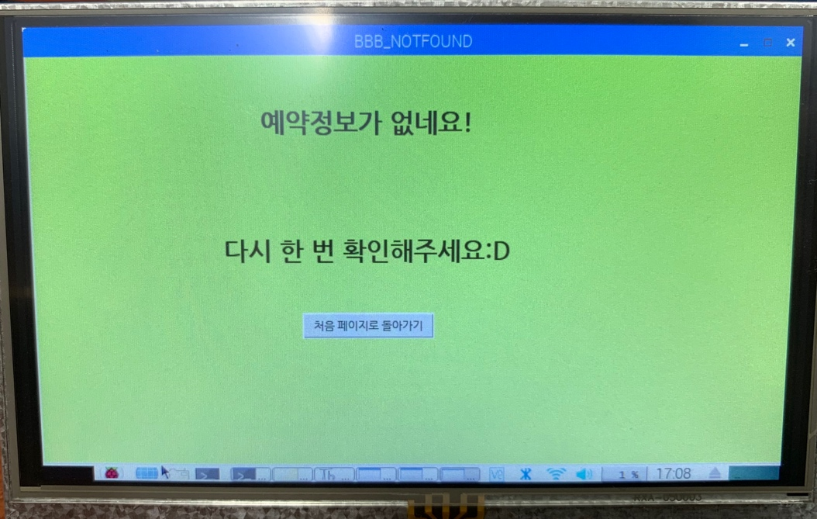If the user is Seller, and the reservation is not true, the user will cannot do further step.

**(1) Recognize Barcode**

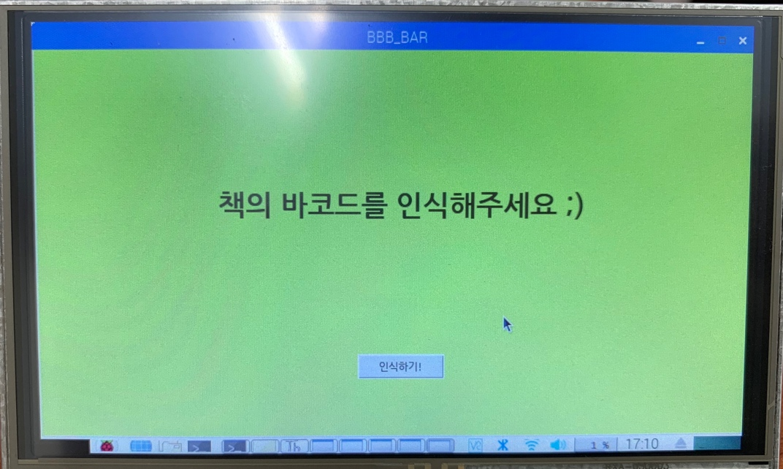However, if reservation is true, user need to recognize barcode of the book which he/she sold. And book box is ready to check whether the book is right one or not.

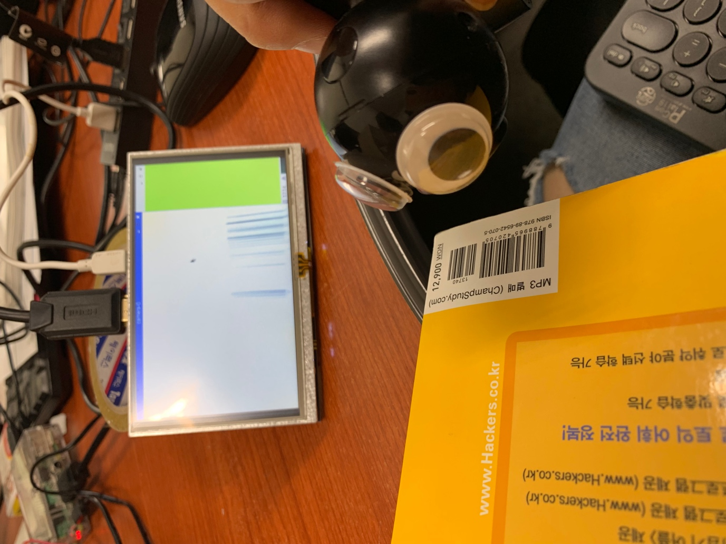

**Check ISBN**

After recognize the ISBN, check this ISBN is same with the data which Book box already have through recognizing QR code.

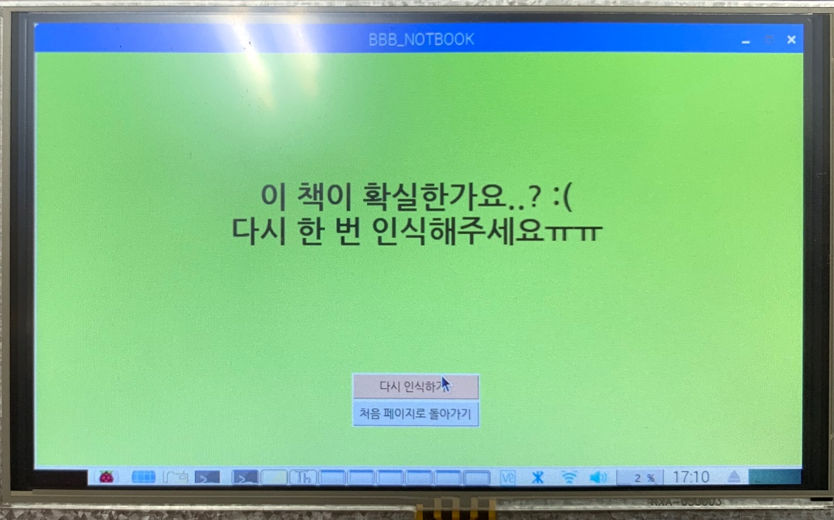If ISBN is not same, seller should re-recognize the barcode or should stop the steps.

1. **Lock/unlock the book box**

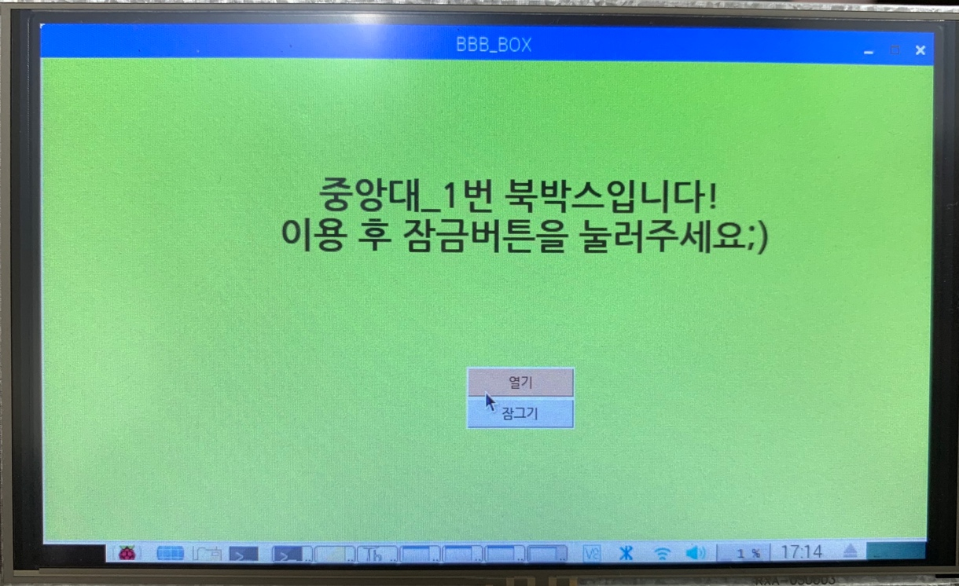However, the book is right one, seller can unlock the book box and put the book for a buyer.

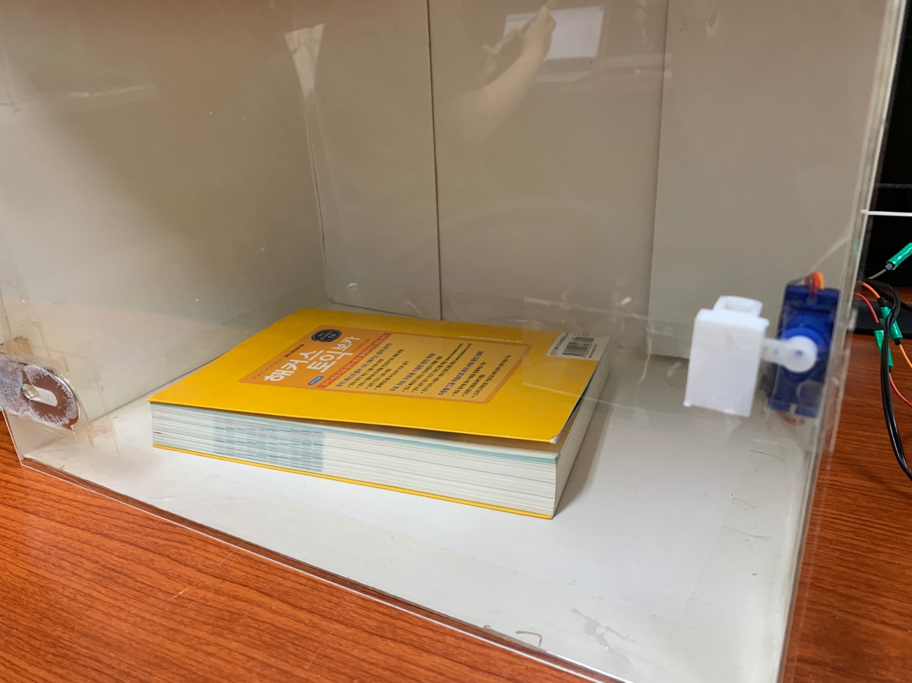After seller put the book and lock the book box, Book box send information about this to server. Through this, buyer can get alarm that notice him/her to take the book.

**Box is locked**

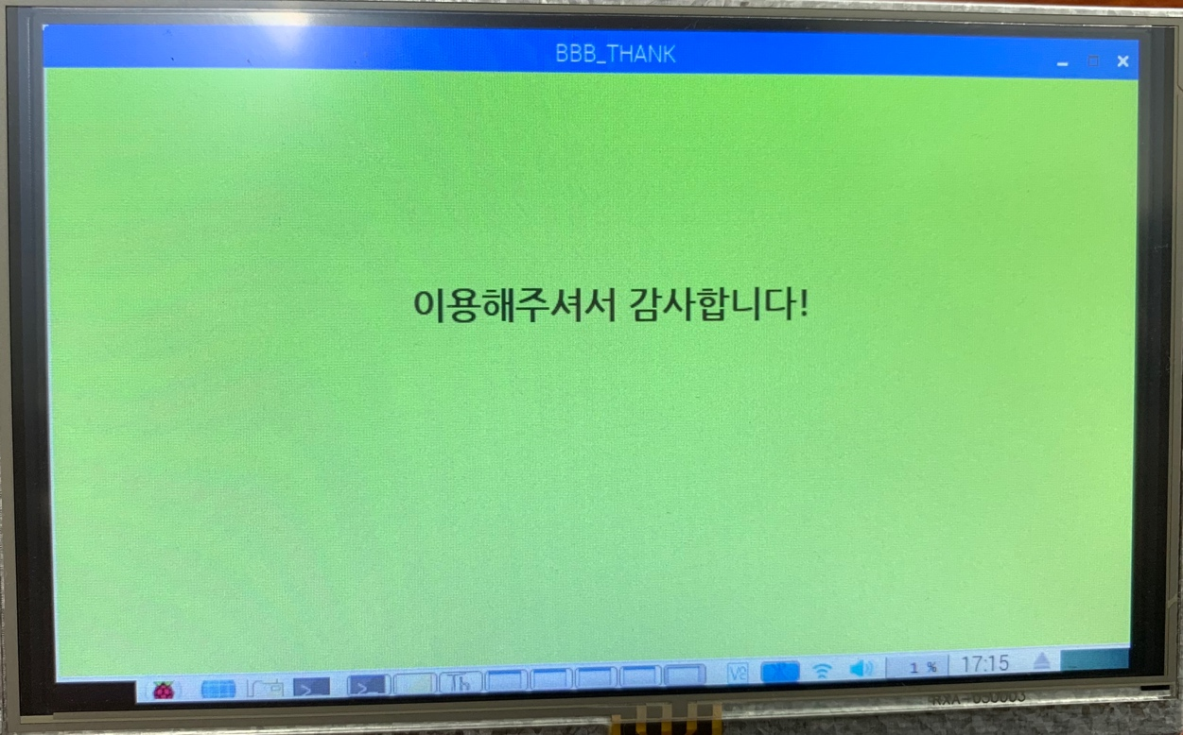**(3) Thank message**

## **Buyer**

1. **Lock/unlock the book box**

If the user is buyer while the reservation is true, buyer also can lock/unlock the book box to take book.

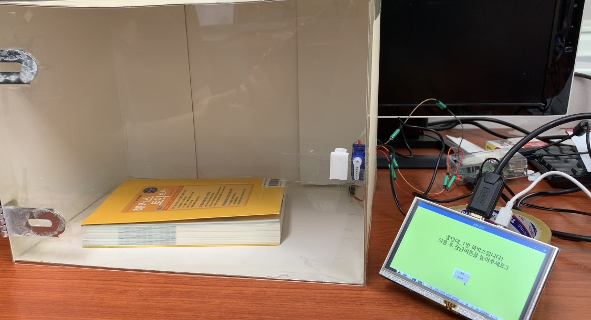After a buyer take his/her book, he/she should confirm purchase in 10 minutes or report and cancel the purchase if there is a problem.

**Box is unlocked**

**(2) Thank and inform message**

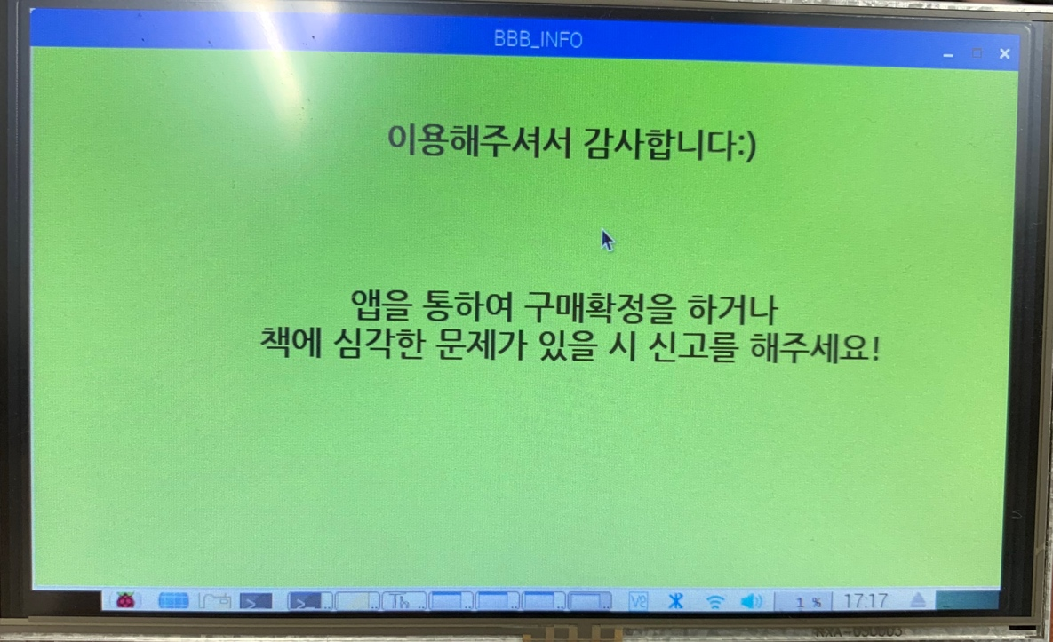Book box will notice this to a buyer at the end of step.